Keep score

Main Success Scenario:

1. Group arrives at the lane; Tablet shows the previous group's final scores.
2. Bowler presses Start Over; Tablet clears the names and scores and shows name entry.
3. Bowler enters the group's names in bowling order and starts the game.
4. Tablet shows whose turn it is.
5. Bowler rolls; Pinsetter sends "1st roll, n"; Tablet records it in that bowler's frame.
6. Bowler rolls again; Pinsetter sends "2nd roll, total"; Tablet works out the second ball, scores the frame, and shows the next bowler.
7. Group repeats steps 4–6 until every bowler has finished the 10th frame.
8. Tablet shows the final scores and waits.
9. Group leaves the lane.
10. Group pays at the main desk for the games they played. OPEN: how the desk knows how many games that was.

Extensions:

1a. Tablet shows name entry (the previous group pressed Start Over):
1a1. Use case continues at step 3.

1b. Tablet shows a game in progress (the previous group left mid-game):
1b1. Bowler presses Start Over.
1b2. Tablet asks "End this game?".
1b3. Bowler confirms; use case continues at step 3.

1b3a. Bowler does not confirm:
1b3a1. ✋ Tablet keeps the old game on screen.

2a. Bowler presses Next Game instead of Start Over:
2a1. Tablet starts a new game with the previous group's names and order.
2a2. OPEN: this game is charged to the previous group. What stops it, or catches it?

3a. ✋ Bowler mistypes a name or gets the order wrong:
3a1. Bowler corrects the names or order; allowed until the first ball is rolled.

3b. OPEN: the smallest and largest number of bowlers in a game.

5a. Bowler knocks down all 10 pins on the 1st roll (strike):
5a1. Pinsetter sends "1st roll, 10" and sets a new ten.
5a2. Tablet scores a strike and shows the next bowler; use case continues at step 4.

5b. Pinsetter's message never arrives:
5b1. Group goes to the main desk; play on the lane waits.
5b2. OPEN: in the trial, what does the desk do to get the lane going again?

5c. Pinsetter reports the wrong count:
5c1. Bowler goes to the main desk before the next ball is thrown.
5c2. Desk staff fix the count in the pinsetter app's override.
5c3. Trial iteration: Tablet is not told; the wrong count stands; use case continues.
5c4. Later iteration: Pinsetter sends "change roll score" for the roll it just sent; Tablet re-scores; use case continues.

5c1a. The next ball has already been thrown:
5c1a1. The count stands; use case continues.

5d. ✋ A different bowler rolls out of turn:
5d1. Tablet credits the roll to whoever it shows as up (Pinsetter knows no players).
5d2. OPEN: does that matter in the trial?

6a. Bowler knocks down the remaining pins on the 2nd roll (spare):
6a1. Pinsetter sends "2nd roll, 10"; Tablet scores a spare; use case continues at step 4.

6b. Pinsetter's message never arrives: as 5b.

6c. Pinsetter reports the wrong count: as 5c.

7a. Bowler gets a strike or spare in the 10th frame:
7a1. Tablet gives the bonus ball or balls the rules allow.

7a1a. The 10th frame ends stuck (strike-strike-non-strike, or spare then a non-strike bonus ball):
7a1a1. Tablet asks the bowler for one free extra ball to clear the lane.
7a1a2. Bowler throws it; Pinsetter clears after its 2nd roll; Tablet ignores that ball's pins.

7a1a2a. Bowler will not throw the clearing ball:
7a1a2a1. The lane stays mid-frame; time passes (neither app has a sense of time); the desk can step in.

8a. Group wants another game:
8a1. Bowler presses Next Game.
8a2. Tablet keeps the names and order and starts a new game; use case continues at step 4.
8a3. OPEN: how the extra game reaches the group's charge.

9a. Group wants their names off the screen:
9a1. Bowler presses Start Over; Tablet shows name entry; use case continues at step 10.

*a. At any time, a bowler tries to change a pin count on the Tablet:
*a1. Tablet offers no way to do it.

VARIANT 1

1. Group arrives at the lane; Tablet shows a blank score sheet with “Enter players”.
(Tablet may still show the previous group's game.
3. Bowler enters the group's names in bowling order and starts the game.
Any bowler can change the names and bowling sequence at any time.
4. Tablet always shows whose turn it is.
(Bowlers may change the bowling order so someone
who hasn’t bowled is above someone who has.
5. After each roll of a bowler frame, the Pinsetter sends roll number (1st or 2nd) and
number of pins knocked down. Tablet updates the score in that bowler's frame
according to the rules of bowling (allowing for previous strikes and spares).
Tablet indicates who the next bowler is and which roll it will be (including the
possible 3 rolls in the 10th frame).
7. Group repeats step 5 until every bowler has finished the 10th frame.
8. After the game, tablet asks: “All done, or new game?
(Bowlers choose which).
9. Group leaves the lane.
10. Group pays at the main desk for the games they played.
OPEN: how the desk knows how many games that was.

Extensions

1a. Tablet still shows the previous group's game :
a. Someone hits “Start over”.
a.a. Previous game was finished: Tablet resets to a blank score sheet
a.b. Previous group left mid-game. Tablet asked “End game and start over?”
a.b.a. Yes: Tablet resets to a blank score sheet.
a.b.b. No: New group takes over old group’s game. ?? Uncertain how billing works
b. Someone hits “New game” with the same players. ?? Uncertain how billing works.
4a. Bowlers may change the bowling order so someone who hasn’t bowled is above someone who has: Tablet shows the person who hasn’t bowled as next bowler.

Conversation:

Seven groups cover them all, in this order: G, T2, T5, T6, T1, T4, T3.

Group 1, 10:00, opening
The manager has the lane set the way they want it. ✋ I'm guessing that means a blank sheet showing "Enter players". The Garcias, three people, type their names and start. After game 1 they press Next Game; they bowl game 2 and walk away. Left on screen: game 2's final scores, with the Garcias' names.

Group 2, The Parks see the Garcias' scores.
They press Start Over; the tablet goes straight to a blank sheet with no "are you sure?" They bowl half a game, get a phone call, and leave in frame 6. Left on screen: a game in progress with the Parks' names.

Group 3, The Okafors press Start Over; the tablet asks "End this game?" and they say No.
- First cut: ✋ the old game stays on screen, and then nothing more is written. The Okafors are stuck.
- Variant: they take over the Parks' game and bowl it out under the Parks' names. Billing is open.

Then they press Next Game (or answer "new game"), change their minds, and leave without bowling. Left on screen: a fresh game with no rolls, under the Parks' names.
- Neither version says whether a game with no rolls counts as "mid-game", or whether it gets charged.

Group 4, The Lindqvists see an empty game under strangers' names and press Start Over. Does the tablet ask "End this game?" here? Neither version says. They bowl one game, finish, and press Start Over (Variant: "All done"?) to take their names off. Left on screen: a blank sheet.
- First cut: 9a covers it.
- Variant: this only works if "All done" clears the screen.

Group 5, The Novaks find a blank sheet, the same as at opening. They enter names, bowl, and leave mid-game in frame 8. Left on screen: a game in progress.

Group 6, The Reyes press Start Over → "End this game?" → Yes, and get a blank sheet. They bowl one game and leave without pressing anything. Left on screen: final scores (Variant: plus "All done, or new game?").
- Both versions agree here.

Group 7. The Tanakas press Next Game (Variant: answer "new game") and bowl under the Reyes' names until closing. The Reyes get charged.
- Both versions mark billing open here. The tablet has no way to tell this group apart from the Reyes playing again.

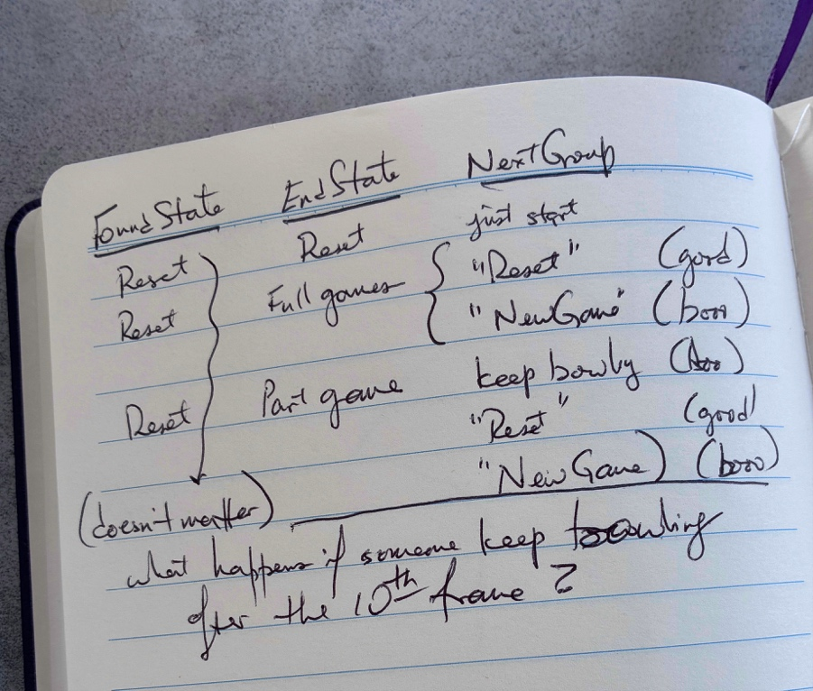

Suggestion:

1. Group arrives; Tablet shows the reset state: a blank score sheet and “Enter players”.
(Tablet may still show the previous group's game.
3. Bowler enters the group's names in bowling order and starts the game.
Any bowler can change the names and bowling sequence at any time.
4. Tablet always shows whose turn it is.
(Bowlers may change the bowling order so someone
who hasn’t bowled is above someone who has.
5. After each roll of a bowler frame, the Pinsetter sends roll number (1st or 2nd) and
number of pins knocked down. Tablet updates the score in that bowler's frame
according to the rules of bowling (allowing for previous strikes and spares).
Tablet indicates who the next bowler is and which roll it will be (including the
possible 3 rolls in the 10th frame).
7. Group repeats step 5 until every bowler has finished the 10th frame.
8. After the game, tablet asks: “All done, or new game?
(Bowlers choose which).
9. Group leaves the lane.
10. Group pays at the main desk for the games they played.
OPEN: how the desk knows how many games that was.

Extensions

1a. New group arrives: Here are the possible movements:

Found state | New ppl action | Result
Set to blank | Just start w names | Just start new group
Prev group game done | “Reset” | Reset for new group
Prev group game done | “New game” | New game, broken billing
Prev group game open | “Reset” | Reset for new group
Prev group game open | “New game”/  “End game and start new game?” /  “Yes” | New game broken billing
Prev group game open | “New game”/  “End game and start new game?” /  “No” | Cheaters. Broken billing
Prev group game open | Continues bowling | Cheaters. Broken billing

❯ and ... I like that expanding the table this way finally forces me to confront the question of what the business rule is for billing and handling when a group leaves, pays, and doesn't reset the tablet

3rd Try:
Keep score

Precondition: At the beginning of the day and after every group pays, the manager uses the Lanes Manager App (LM app) to reset the ScoreKeeper app (the Tablet) to a blank and empty game, with the instruction to “Enter Players”. When a new group arrives, the Tablet shows this reset state.
1. Bowler enters the group's names in bowling order and starts the game.
2. The Tablet always indicates whose turn it is, which roll it is and how many games are being charged.
A game is charged the moment the first roll is made. Charges are for games /started/ not games /finished/.
3. After each roll, the Pinsetter sends roll number (1st or 2nd) and number of pins currently down.
The Tablet updates the score in that bowler's frame according to the rules of bowling.
Tablet indicates who the next bowler is and which roll it will be (including the
possible 3rd roll in the 10th frame).
4. Group repeats step 5 until every bowler has finished the 10th frame.
5. Bowlers choose whether to start a new game, or go and pay for the games they bowled.
6. When the Group pays at the main desk for the games they played, the manager has the LM app reset the Tablet for the next group.
(separate use case, showing dialog of # games to charge, followed by the reset)
*a. Any bowler can change the names and bowling sequence at any time.
This may produce the situation that someone who hasn’t bowled in this frame is above
someone who has. The Tablet calls for the appropriate next person to bowl.
*b. A new player is added part way through the game:
The Tablet enters them with rolls of zero until they are caught up with the rest of the people.

1a. Someone rolls a ball before names have been entered, the pinsetter sends the roll information:
The Tablet starts the game, calling the bowler “Player 1”
In case more rolls are done before adding other players, the tablet considers this a 1-person game.
3a. A 3rd roll in 10th frame leaves 2nd roll dangling (eg X.X.3, or 5./.2, although X.3.4 is not a problem):
Tablet asks the bowler to bowl one more roll just to clear the pinsetter.
it ignores the number the pinsetter sends.
3b. Pinsetter reports incorrect number of pins down:
Bowler goes to the main desk.
Desk staff fix the number in the pinsetter.
Pinsetter sends “Correct roll score” to the tablet (roll number, number of pins down).
Tablet updates the score and bowling continues.
3c. Case 3b but a bowler has already bowled the next ball before the pinsetter got corrected:
The correction is ignored. (Actually, I don’t think this can happen, but ok).
w

Extensions out of scope:
1b. Too many bowlers for the lane
3d. Pinsetter's message never arrives (the tablet can’t detect)
3e. A bowler rolls out of turn (the tablet can’t detect)
3f. A pinsetter message arrives out of order
6a. The group leaves without paying

